# Using the Geonames API

In order to use the goenames api you do need a single key. This can be obtained by simply signing up on he website. The following instructions illustrate this process.

1. Go to the geonames website at <http://www.geonames.org/>  
   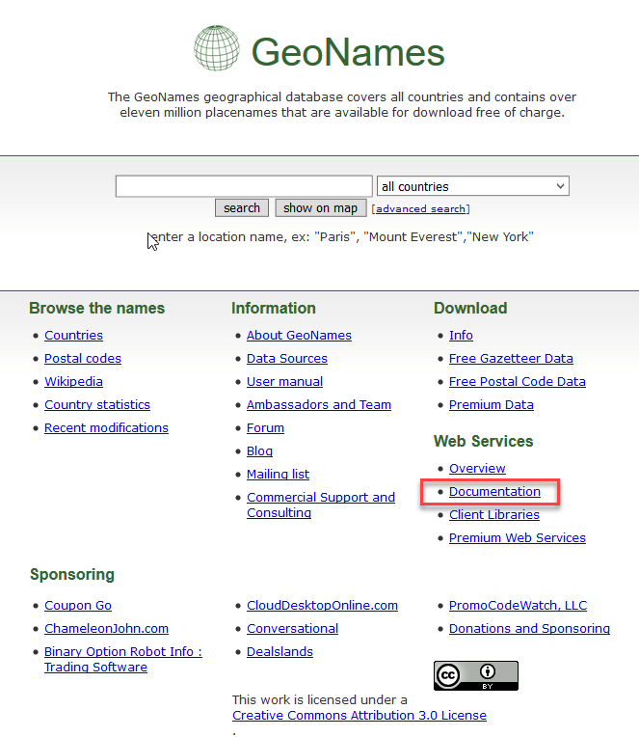
2. Under Web Services click on documentation  
   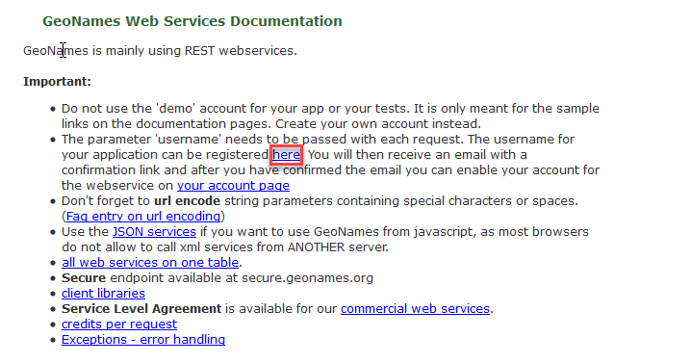  
   and then click the here link.
3. Complete the simple sign-up form  
   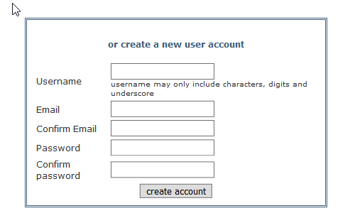  
   The Username you choose will act as your key.
4. When you have completed the form and clicked create account, you will be sent an email asking you to activate your account.
5. After you have activated the account the logon page is changed to provide a link to click to allow you to use the Web services  
   